1

Now review and Create

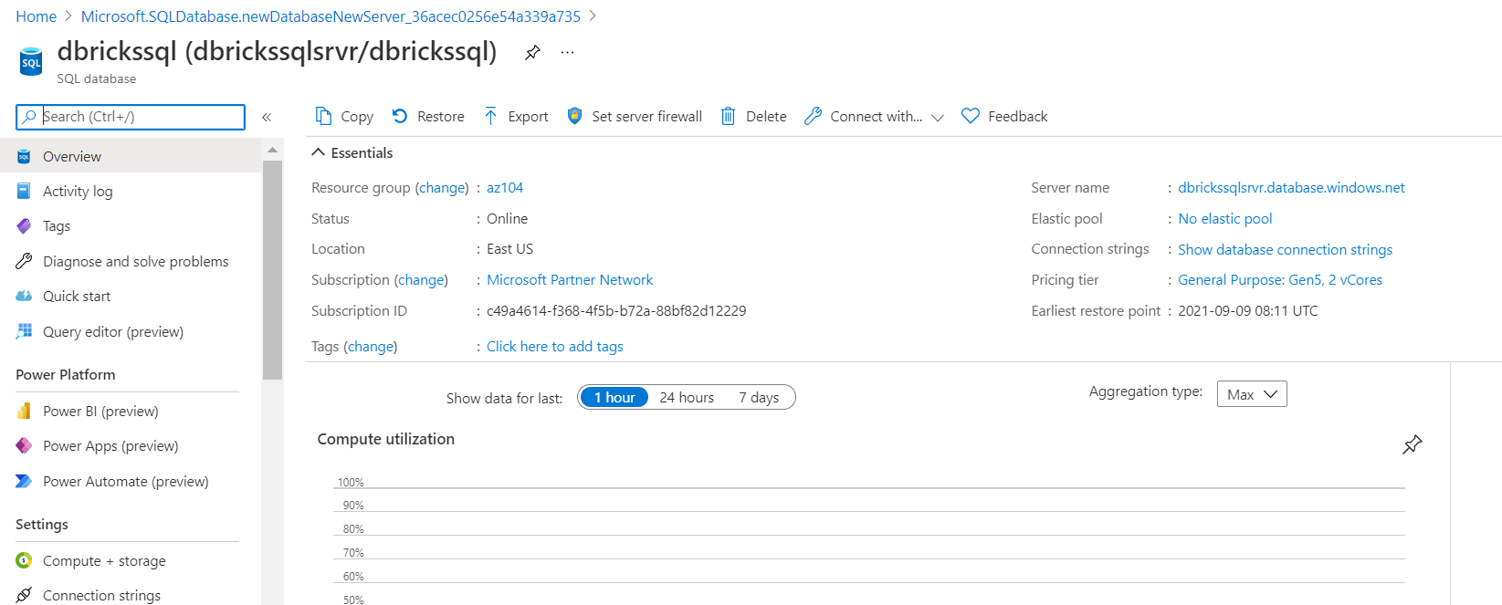

Noite down the server addfress

Create New Table and upload the CSV file

Notedown the oath

Create new Notebook

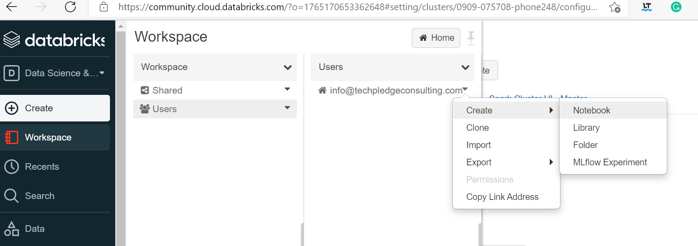

Launch workspace

Create Cluster

Upload data

Type the script and cliek run to execute it\

from pyspark.sql import *

import pandas as pd

jdbcHostname = "dbrickssqlsrvr.database.windows.net"

jdbcPort =1433

jdbcDatabase ="dbrickssql"

properties = {

"user": "dbadmin",

"password": "Password@123"

}

url = "jdbc:sqlserver://{0}:{1};database={2}".format(jdbcHostname, jdbcPort, jdbcDatabase)

filedf = sqlContext.read.csv("/FileStore/tables/BDCS_DIY_Sales.csv", header=True)

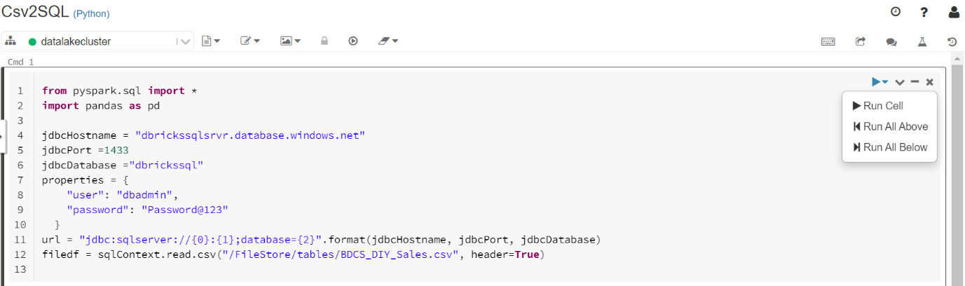

Now Run the script

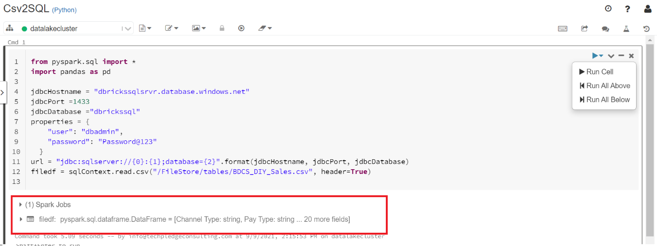

Now add additional Line

from pyspark.sql import *

import pandas as pd

jdbcHostname = "dbrickssqlsrvr.database.windows.net"

jdbcPort =1433

jdbcDatabase ="dbrickssql"

properties = {

"user": "dbadmin@dbrickssqlsrvr",

"password": "Password@123"

}

url = "jdbc:sqlserver://{0}:{1};database={2}".format(jdbcHostname, jdbcPort, jdbcDatabase)

**filedf = sqlContext.read.csv("/FileStore/tables/BDCS_DIY_Sales.csv", header=True)**

**filedf = filedf.withColumnRenamed("_c0", "id")**

**filedf1 = DataFrameWriter(filedf)**

Now add last line to write to database

from pyspark.sql import *

import pandas as pd

jdbcHostname = "dbrickssqlsrvr.database.windows.net"

jdbcPort =1433

jdbcDatabase ="dbrickssql"

properties = {

"user": "dbadmin@dbrickssqlsrvr",

"password": "Password@123",

"driver": "com.microsoft.sqlserver.jdbc.SQLServerDriver"

}

url = "jdbc:sqlserver://{0}:{1};database={2}".format(jdbcHostname, jdbcPort, jdbcDatabase)

filedf = sqlContext.read.csv("/FileStore/tables/BDCS_DIY_Sales.csv", header=True)

filedf = filedf.withColumnRenamed("_c0", "id")

filedf1 = DataFrameWriter(filedf)

**filedf1.jdbc(url=url, table="sales", mode="overwrite", properties=properties)**

**Now go to sql and qyery editir**

**Add the up to dfirewall**

**Lab 2**

Click Revuew abd Create

Notedown the dfatalake URL , change the **https to adl**

adl://ispdata.dfs.core.windows.net

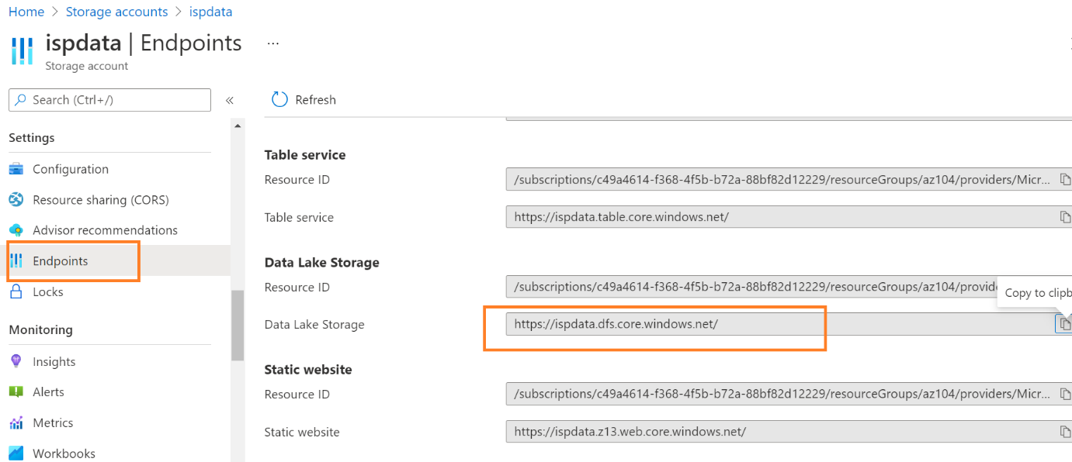

Go to azure ad

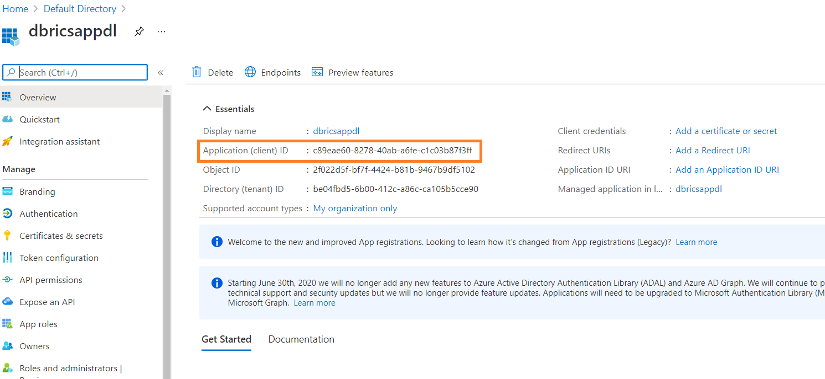

Notedown app id : c89eae60-8278-40ab-a6fe-c1c03b87f3ff

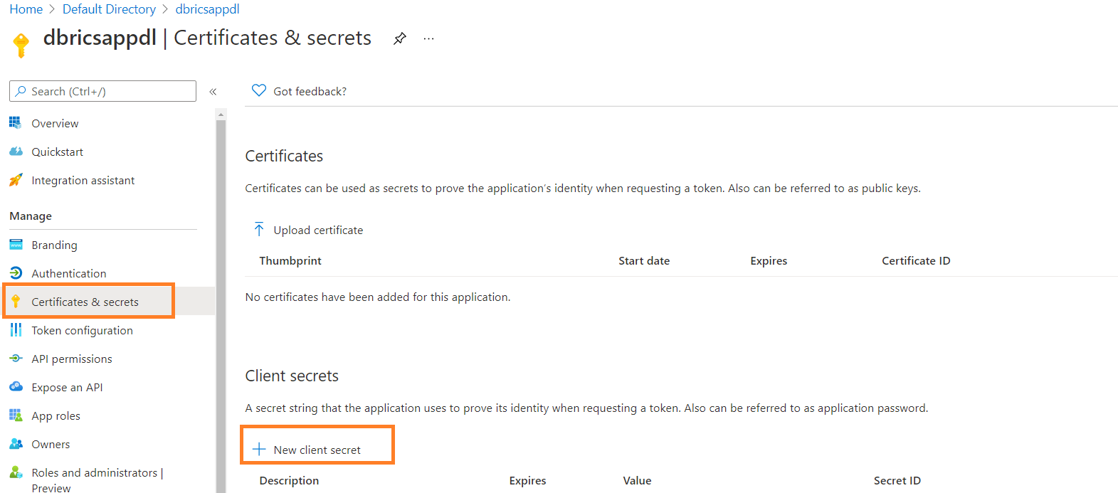

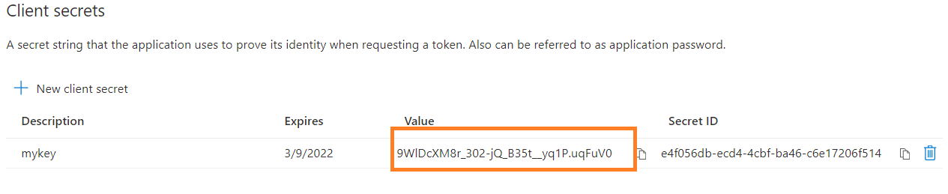

Copy the key

9WlDcXM8r_302-jQ_B35t__yq1P.uqFuV0

Get the tenant ID

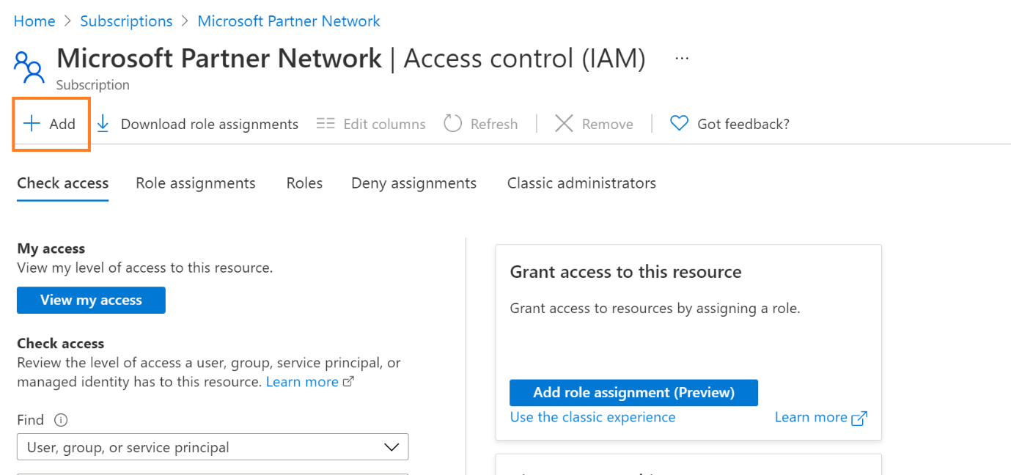

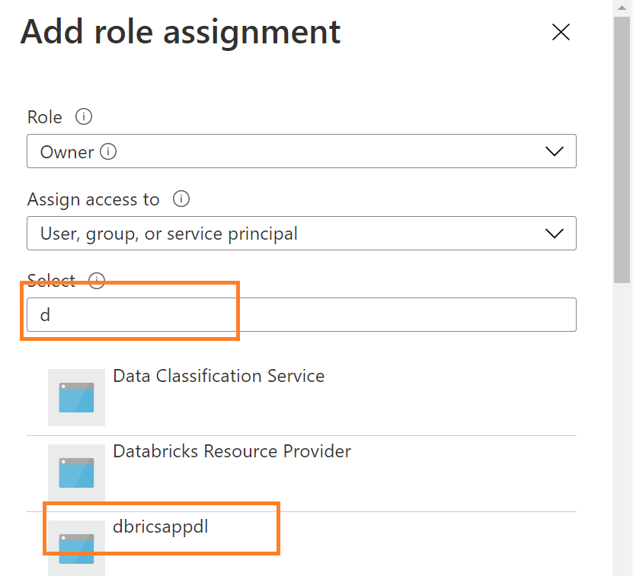

dbutils.fs.mkdirs("/mnt/mountdatalake")

configs = {"dfs.adls.oauth2.access.token.provider.type":"ClientCredential",

"dfs.adls.oauth2.client.id": "c89eae60-8278-40ab-a6fe-c1c03b87f3ff",

"dfs.adls.oauth2.credential": "G2vtQpSq8G2djgf.W.U3PTi0fnXV-_oF.e",

"dfs.adls.oauth2.refresh.url": "https://login.microsoftonline.com/be04fbd5-6b00-412c-a86c-ca105b5cce90/oauth2/token"}

dbutils.fs.mount(

source = "adl://ispdata.dfs.core.windows.net/mountdatalake",

mount_point = "/mnt/mountdatalake",

extra_configs = configs )

Now the softlibnk created , lets now write the data from sql top datalkaken

\

\

Create new nioreb book

Now write below code firsty tp creaed from sql

from pyspark.sql import *

import pandas as pd

jdbcHostname = "dbrickssqlsrvr.database.windows.net"

jdbcPort =1433

jdbcDatabase ="dbrickssql"

properties = {

"user": "dbadmin@dbrickssqlsrvr",

"password": "Password@123",

"driver": "com.microsoft.sqlserver.jdbc.SQLServerDriver"

}

url = "jdbc:sqlserver://{0}:{1};database={2}".format(jdbcHostname, jdbcPort, jdbcDatabase)

pushdown_query = "(select * from dbo.sales) as sales"

print(pushdown_query)

# This Panda read the data from sql

df2 = spark.read.jdbc(url=url, table=pushdown_query, properties=properties)

You should see the outrput as

Now add new line to read data from sql and write to datalake

from pyspark.sql import *

import pandas as pd

jdbcHostname = "dbrickssqlsrvr.database.windows.net"

jdbcPort =1433

jdbcDatabase ="dbrickssql"

properties = {

"user": "dbadmin@dbrickssqlsrvr",

"password": "Password@123",

"driver": "com.microsoft.sqlserver.jdbc.SQLServerDriver"

}

url = "jdbc:sqlserver://{0}:{1};database={2}".format(jdbcHostname, jdbcPort, jdbcDatabase)

pushdown_query = "(select * from dbo.sales) as sales"

print(pushdown_query)

# This Panda read the data from sql

df2 = spark.read.jdbc(url=url, table=pushdown_query, properties=properties)

# This Panda read the write data to datalake

**df2.toPandas().to_csv('/dbfs/mnt/mountdatalake/sales.csv', header='True', encoding="utf-8")**

